**Francesco Spampinato**

**Rhode Island School of Design (RISD), Providence**

**Richard Serra (1939-) – Films and Videos**

The American artist Richard Serra emerged in the 1960s in association with the Minimalism art movement. Known primarily for his work as a sculptor, he also realized several films and videos in the 1960s and 70s, which could be divided into two groups: 16mm. films mainly concerned with sculptural issues and videos that explore the influence of the mass media.

The first group includes *Hand Scraping* (1968) and *Hand Catching Lead* (1968), whose titles alone are illustrative of their content. Defined by Benjamin H. D. Buchloh as “sculptural films,” they explore the nature of sculpture as process and seriality. To this group also belong *Railroad Turnbridge* (1976) and *Steelmill/Stahlwerk* (1979), focused on materials, construction, and industrial production.

The second group of moving image works consists of videos that comment on the mass media as devices of control. *Television Delivers People* (1973) is a series of rolling sentences about the power of television to turn its audience into a product. In *Boomerang* (1974), the artist Nancy Holt (1938–2014) describes her feelings of displacement while listening to her delayed voice, while *The Prisoner’s Dilemma* (1974) is a studio-scale production that compares a TV game show to a police interrogation.

**References and further reading**

Buchloh, B. H. D. (1978) *Process Sculpture and Film in the Work of Richard Serra*, in *Richard Serra: Works ’66–’77*, Tübingen: Kunsthalle

Lee, Pamela (2013), *Game Show: Richard Serra and the Prisoner’s Dilemma* in *New Games: Postmodernism After Contemporary Art*, New York: Routledge

Michelson, A. (1979) ‘The Films of Richard Serra: An Interview’, *October* 10: 68-104

Serra, R. (1974), ‘Interview by Liza Béar: *Prisoner’s Dilemma*’, *Avalanche* 9: 26-29

**Images suggested**

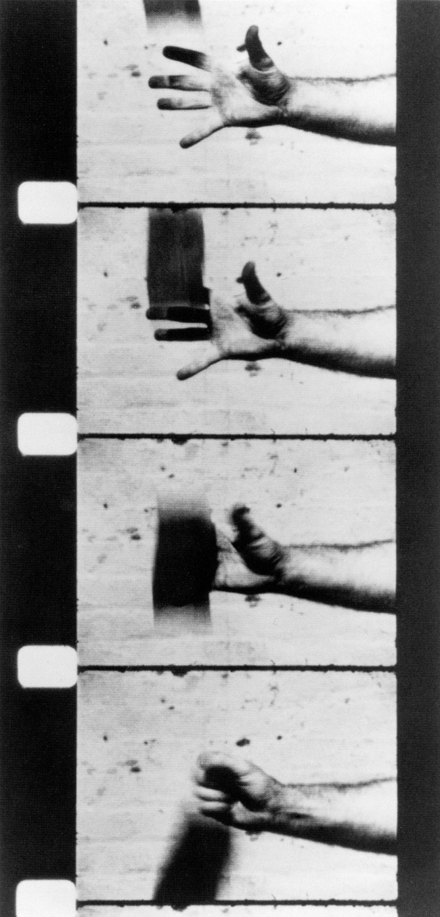

Author: Richard Serra

Title: Hand Catching Lead

Medium: 16mm Film, Silent, B&W

Year: 1968

Duration: 03:30 minutes

Collection: MoMA, New York or Gagosian Gallery, NY/LA

<http://www.moma.org> or <http://www.gagosian.com/>

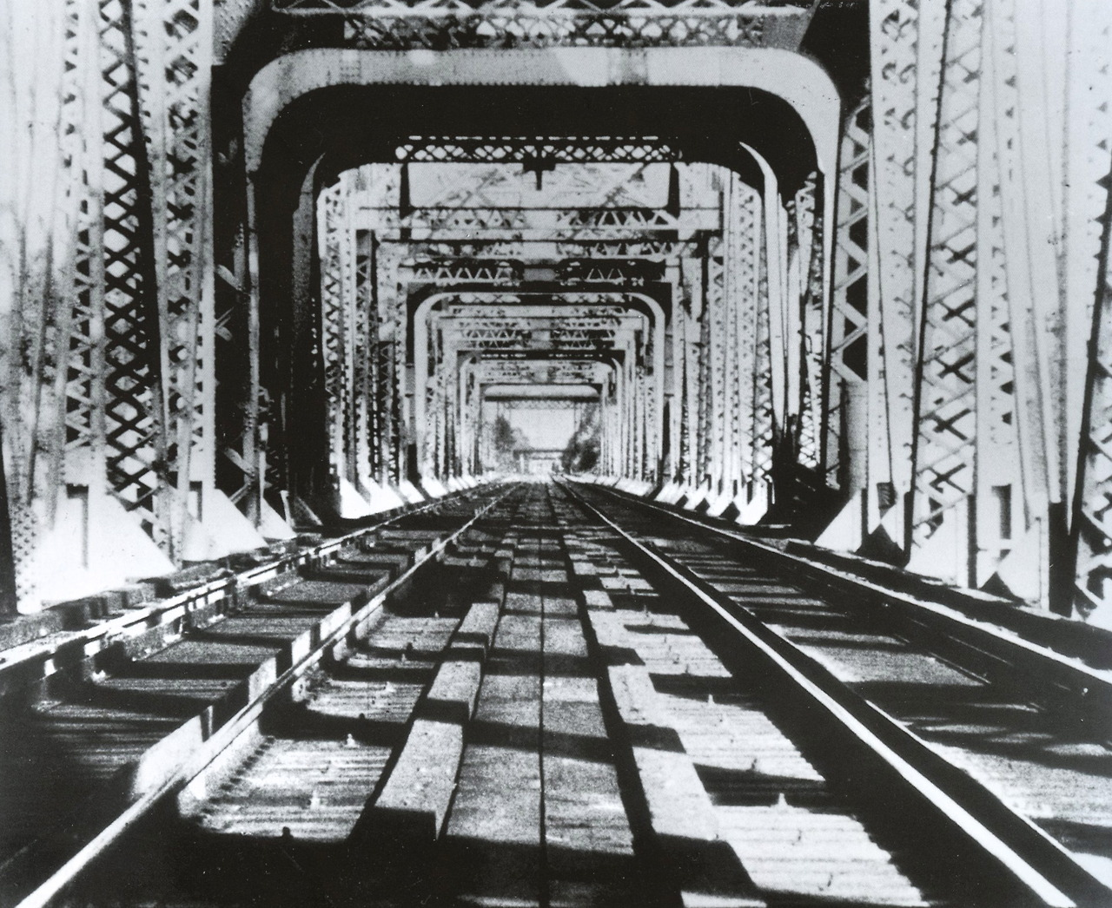

Author: Richard Serra

Title: Railroad Turnbridge

Medium: 16mm film, Silent, B&W

Year: 1976

Duration: 19:00 minutes

Collection: MoMA, New York or Gagosian Gallery, NY/LA

<http://www.moma.org> or <http://www.gagosian.com/>



Author: Richard Serra

Title: Television Delivers People

Medium: 4:3 Video, Sound, Color

Year: 1973

Duration: 05:55 minutes

Collection: Video Data Bank or MoMA, New York

<http://www.vdb.org/titles/television-delivers-people>

<http://www.moma.org/collection/browse_results.php?criteria=O%3AAD%3AE%3A5349&page_number=15&template_id=1&sort_order=1>